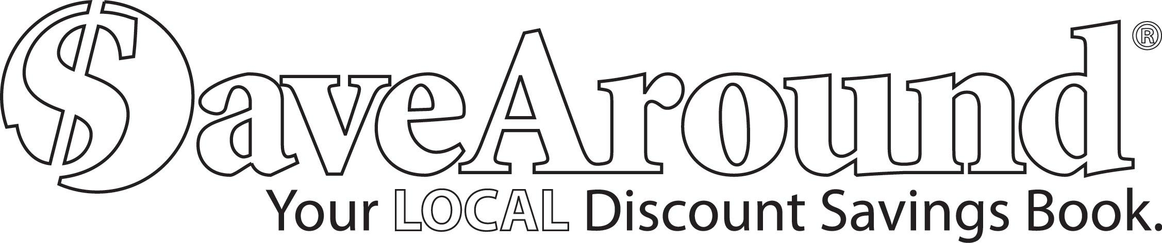

Dear Parents and Friends:
<EDIT> is sponsoring the SaveAround sale to raise funds for{ SaveAround is a coupon book that offers hundreds of buy-one-get-one-free discounts, along with many other great discounts!!
You buy one book for just $25!! You will find out that the book pays for itself after using it just 2 or 3 times. You make your money back and more!!!

The Fundraiser will be coordinated as follows:
Start Date: xx/xx/xxxx
Coupon book and envelope/order form will be sent home with each student. For every 5 books a student sells, he/she will get 1 book FREE!
End Date: xx/xx/xxxx
Please return order form and payment for all orders or unsold book to your child’s teacher. If only one book was sold, please keep your book and return only money and order form. Orders will be filled within 10 days of return.

**All SaveAround book editions can be ordered to benefit our sale

- Seller Delivers - Enter the required information on the envelope to place an order.
- Direct Shipment- Enter the required information on the envelope and we’ll take it from there!
- Online Order- Give this URL www.supportourgroups.com/GN/XXXXXX to your family and friends who live out of town so they can order online and support our fundraiser!

Please make checks payable to:
<EDITt>

- Please have your student return this envelope/order form to their teacher by 10/18/2017 with their NAME on it, and MONEY for additional sales inside.

- Remember, this is NOT meant as a door-to-door sale to strangers. The safety of your student is our first concern. Parents, try to sell to relatives, neighbors and co-workers.

If you didn't sell a book – return the sample book loaned to you by the company.
IT MUST BE RETURNED OR THE SCHOOL WILL BE CHARGED!!

Thank you for supporting your community!!

