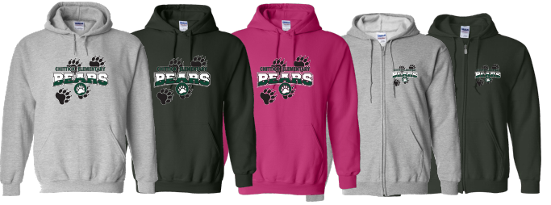

Dear Parents and Friends:
Please show your School Name Spirit by purchasing our comfy apparel and help us raise funds for our _____!
- Choose from awesome new items through our online apparel store using this link: https://saink.com/XXXXX/shop/home
- Share our link: https://saink.com/xxxx/shop/home with friends and family through email, text, and social media!
- All orders MUST be placed by day, Month date.
- Items ordered online will be shipped directly to customers after the fundraiser ends and orders are submitted.
OR
- Items will be distributed to the students in school. Orders arrive to us a few weeks after the end of our sale and all orders are submitted.
For questions, please contact:
XXXX at XXX

Safety Tips:
SaveAround does not promote unsupervised door to door selling! Students should always have adult supervision when selling.
Thank you for supporting our school!

