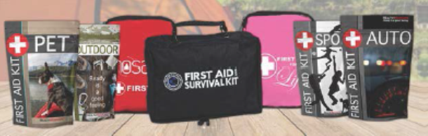

Dear Parents and Friends:

We are selling the SaveAround First Aid Kit to raise funds for our School. We earn 50% profit for each kit sold! You will see that there is a kit for every situation and they will make great additions to your home, car and business! Show the brochure to family, friends and coworkers…
Here is how the First Aid Kit Fundraiser works:
- Price of the first aid kits range from $15-$120
- Please make checks payable to __________.
- Money should be collected when the order is placed.
- Please return the completed order form and all payments in an envelope labeled “SaveAround First Aid Kit Sale” to your teacher.
- Please be sure to include the student's name and teacher’s name/classroom on the front of your envelope.
- Orders will be delivered after the fundraiser ends and orders are submitted.

** When ordering, please follow the directions on the back of the order form. **

For questions please contact:
Contact name by email at: xxxx@xxx.com

All orders are due by Day of week, Month Day.

Safety Tips:
SaveAround does not promote unsupervised door to door selling!
Students should always have adult supervision when selling.

Thank you for supporting our School!

