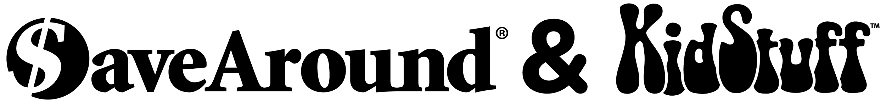

Dear Families & Friends,
We are excited to offer our families and friends the opportunity to purchase these valuable 2023 Coupon Books. The book includes a 12-month Savings App with thousands of additional local and national coupons...save on the go using your phone! Everyone can save a lot of money and help us raise much needed funds for our school!
For every 5 books you sell, you get 1 book FREE!
* To receive credit for sales and earn prizes, Seller’s name must be submitted with book orders.
EASY WAYS TO SELL AND PURCHASE BOOKS...FREE SHIPPING!
ORDER/SELL BOOKS ONLINE with a CREDIT/DEBIT card:
- Go to SAPayNow.com/xxxx
- Please complete all fields
- After selecting the book by State and Edition, CLICK ON ‘Select how you will receive your book’
- Select “Have my book” to pay with a credit/debit card for the book that was sent home with your student
- Select “Add another book” to order additional books and choose your delivery
- "Seller deliver to me” -Seller will deliver your order to you at the end of our sale
- “Ship Books (Free Shipping)” -SaveAround will ship orders directly to you and your supporters
- Post, email, and text our SAPayNow.com/xxxx link to family, friends and coworkers so they can purchase books! They will enjoy saving money and supporting our school too!

ORDER/SELL BOOKS with CASH OR CHECK:
1. Please complete all customers’ order information and your Student’s information on the order form (attached to this letter or on the first page of the National Section of the book).
2. Please make checks payable to __________.
3. Return the completed order form in an envelope with cash and checks enclosed to your teacher. Please include on your envelope: “Coupon Book Sale”, student’s name, phone number, and teacher.
4. Pay for and keep the book sent home. Your additional orders paid for with cash and checks will be sent home at the end of our sale.
Please see the book cover to register your APP for additional savings on your phone!
If you did not sell or purchase books:
1. Please immediately return the book in a bag with your student’s name clearly printed on it to your teacher. We track books that were sent home and need the unsold books to fill orders…thank you!
2. Our school will be charged if the book is not returned.
If you have any questions, please contact: xxxxxxxxx at xxxxxx@xxx.com

Orders & Payments Are Due By: day, month, date.

Remember, safety first! Parents, please sell to relatives, neighbors, and coworkers.
Many THANKS for supporting our school!!

